* **Activity 8:**

Retrieving Records with Non-Equijoins

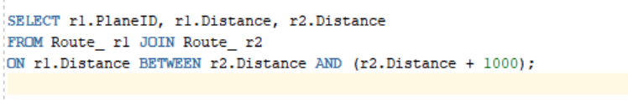

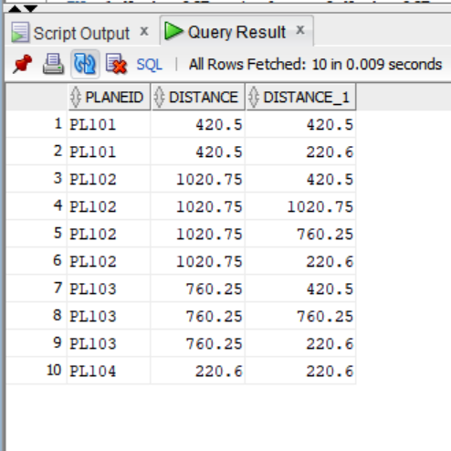OUTPUT: